2.1 Problem Statement – ComicCraft
ComicCraft addresses the difficulty of creating a complete comic when a user has a story idea but does not have professional drawing, writing or comic-design skills.
The problem statement canvas identifies the customer problems, needs, current difficulties and tasks that can be made easier through ComicCraft.
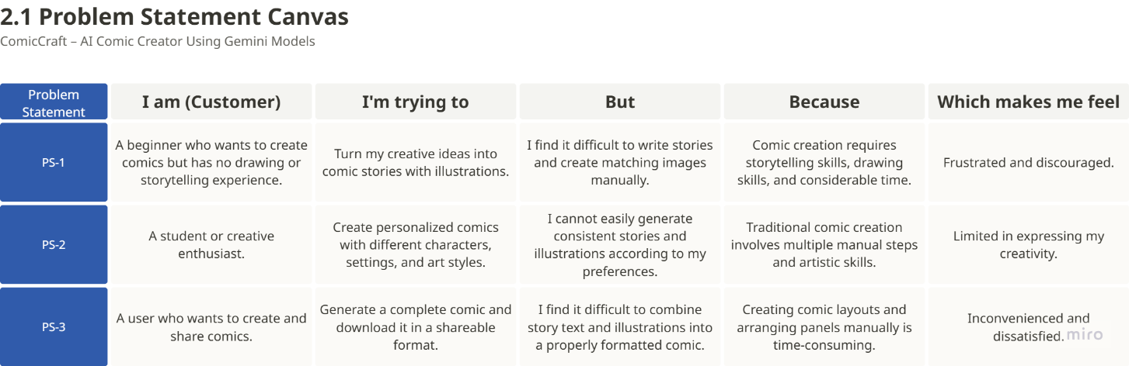
Problem Statement Canvas

